ГУО «Гимназия имени И.М. Ерашова г.Лепеля»

**ПЛАН-КОНСПЕКТ**

**Открытого урока в 6 классе**

**по теме: «Минск – столица Беларуси»**

Подготовила учитель английского языка

2 категории Заяц Екатерина Александровна

2013

**Цель урока:** обобщение материала и систематизация знаний по теме «Минск»

**Задачи: Образовательные:** Обеспечить в ходе урока повторение лексических единиц по теме «Минск», продолжить формирование навыков диалогической и монологической речи.

**Развивающие:** создать условия для развития коммуникативных навыков через разнообразные виды речевой деятельности (монологическую и диалогическую речь), создать условия для развития памяти и внимания.

**Воспитательные:** способствовать развитию культуры взаимоотношений при работе в парах, содействовать формированию патриотических чувств.

1. **Org. moment** Good afternoon. How are you?

Today we have a wonderful opportunity to go on an exciting trip to one of the most beautiful cities in the world, to the capital of our Motherland. We will read some texts about Minsk, we’ll make an excursion in modern Minsk and watch a film and at the end of the lesson you will be able to make up dialogues about sights near Minsk.

1. **Phonetic exercises**

T: And we will travel with the help of the flying carpet. Let’s read a poem. (читать как «Эхо»)

If I had a flying carpet

Carrying me through the air

I would make a lovely trip

Getting everywhere

What countries would I visit?

What cities would I see?

To learn things in our country

How exciting that would be!

1. **Warm-up** We learnt a lot of interesting things about our Motherland and different countries of the world in our English lessons. We have got to know that almost every country has got its symbols. Look at the slide. Let these pictures remind you of the countries we have spoken about.

**The birch tree – Russia**

**The maple leaf – Canada**

**The thistle – Scotland**

**The Stars anв Stripes – the USA**

**The red rose – England**

**The kiwi – New Zealand**

**The kangaroo – Australia**

**Mount Fuji – Japan**

And what are the symbols of our country?

**Pupils**: the cornflower, the white stork, the European bison …

1. **Speaking**  Dear friends, do you know that not only countries, but every city has its symbols? Let me show you some of them.

**Big Ben – London**

**The Eiffel Tower – Paris**

**The skyscrapers – New York**

**The Kremlin – Moscow**

**The Statue of Jesus Christ the Redeemer – Rio-de-Janeiro**

**The Coliseum – Rome**

And what are the symbols of Minsk?

**Pupils:** Independence Square, Pobeda Square, the Circus, the National Library…

Teacher: Every city has its emblem. Have you ever seen the emblem of Minsk? We’ll show you. (Appendix 2) (Учащиеся читают отрывки текста, развешенного по классу. Их задача соединить его и ответить на вопрос).

**What is the emblem of Minsk?**

T: Tell me please, what associations you have with the word Minsk.

Учащиеся называют достопримечательности Минска.

T: Agree or disagree with the statements:

1. Grodno is the capital of Belarus. (D)
2. Minsk is the biggest city in our country. (A)
3. Belarus doesn’t have beautiful nature. (D)
4. The symbol of Belarus is stork. (A)
5. There are no lakes in Belarus. (D)
6. There’s only one castle in Belarus. (D)

**Teacher:** Now, dear friends, we are going to make an exciting tour into the past of our capital. You will have a wonderful opportunity to see Minsk of old days with your own eyes. I hope you will learn some new facts and enlarge your knowledge. Work in pairs. Read the parts of the text and answer the questions. (Appendix 3).

1. **Listening** T: Let’s watch a film about Minsk. (<http://youtube.com/watch?v=ZP1E28TKFP0>) While watching you should answer the question: What places of interest from this list were mentioned in the video?

**National Art Museum Underground Shopping Center**

National Library Gorky Park

**Independence Avenue** Cheluskintcev Park

October Square **Town Hall**

**Say if the statements are true or false:**

1. People are friendly in Minsk.(true)
2. Minsk has badly-developed transport system. (false)
3. Minsk is located in forest region. (true)
4. Independence square is known as Lenin Square. (true)
5. The House of the Government is situated in Victory Square. (false)
6. **Speaking** T: Are there any places of interest in Minsk?

Ps: Yes, there are.

T: Mach the pictures with the places of interest:

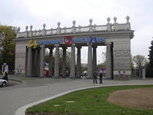 Gorky park

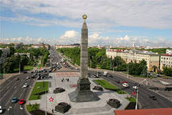 Victory square

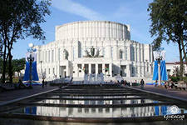 The Opera and Ballet House

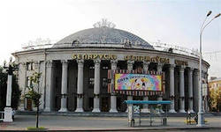 The State Circus

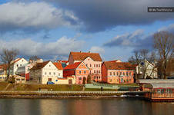

The Trinity Suburb

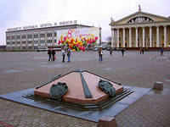 October Square

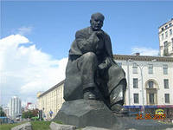

The monument to Kolas

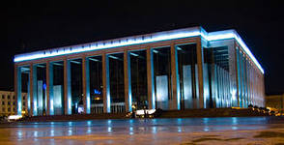

The Palace of the Republic

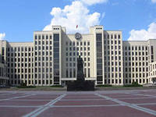

The House of the Government

T: Can you make a short excursion on these places of interest?

Ps: With great pleasure.

**Высказывания учащихся о Минске (Appendix 4)**

1. **Physical exercises**

**Up, down, up, down** (руки вверх и вниз)

**Which is the way? (разводим руки в стороны)  
to Minsk town?**

**Where? Where?** (поворачиваемся в стороны)

**Up in the air?** (смотрим вверх)

**Close your eyes** – (закрываем глаза)

**And you are there!** (открываем глаза)

1. **Speaking (work in pairs)**

T: Look at the pictures. What places of interest are they?

Ps: They are Dududki, “Raoubichi”, Lake Naroch.

T: I’ve got some dialogues about these sightseeing, but the lines of these dialogues are mixed. Help me please to make them correct and role-play them. Listen to your partners attentively and say what sightseeing is the farthest from Minsk.

**Dialogue 1.**

* Have you ever visited Dududki?
* Yes, I have. It’s an open-air museum near Minsk.
* How far is it from our capital?
* It’s only 40 km from Minsk.
* What is it famous for?
* It’s a museum of handicrafts.
* What do you like there best?
* I liked bakery.
* Would you like to visit it one more time?
* With great pleasure.

**Dialogue 2.**

- Do you know anything about sport complex “Raoubichi” ?

- It was built for ski competitions.

- Is it a popular place among tourists?

- Yes, they can stay in comfortable 3-star hotels and lovely little cottages there.

- Are there any historical monuments near?

- A Cross Mount Roman-Catholic church with a museum of local costume is situated there.

- Is it far from Minsk?

- No, only 22 km.

**Dialogue 3.**

* What is Narochansky land famous for?
* It’s famous for Lake Naroch, a pearl of the Belarusian Nature.
* How many lakes are there?
* There are 42 lakes.
* Is it famous only for its lakes?
* No, it isn’t. there are wonderful forests and golden beaches on the Narochansky land.
* Is it far from Minsk?
* Yes, it’s rather far. It’s 170 km from Minsk.

1. **Home-task**

At home you’ll make a photo-album of Minsk:

1. For children
2. For visitors from another country
3. For visitors from another planet
4. **Reflexion**

Where, where have you been?

What, what have you seen?

What, what have you done?

Have you had a lot of fun?

**Appendix 1.**

В качестве рефлексии также можно предложить вытянуть вопрос из «Волшебной шкатулки» и ответить на него.

Примеры вопросов:

1. When was Minsk founded? (1067)
2. How many people live in Minsk? (about 2 million people)
3. When was the new railway station built? (in 2001)
4. What is the oldest place in Minsk? (the Trinity Suburb)
5. What can you visit in the Trinity Suburb? (a lot of cafes, small shops and museums)
6. Which theatre is the most beautiful in Minsk? (the Opera and Ballet House)

**Appendix 2.**

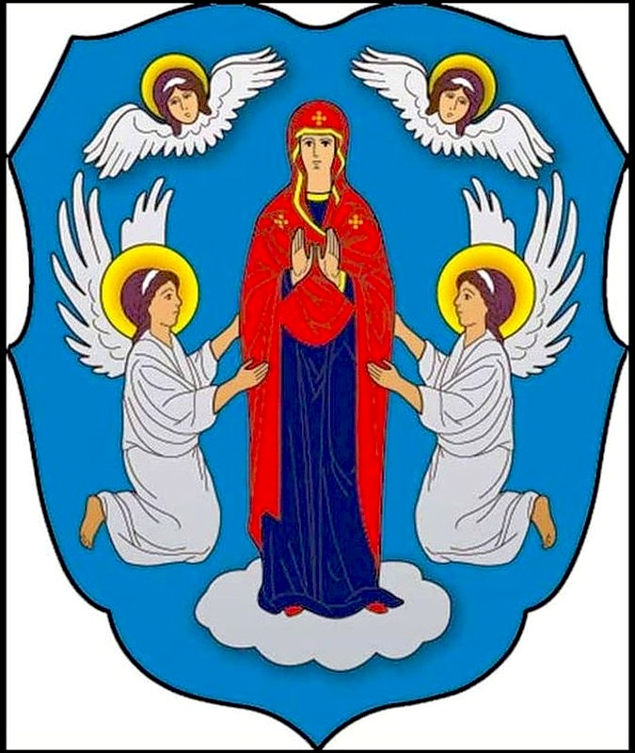

**Every city had its emblem. Have you ever seen the emblem of Minsk? We’ll show you. You see St. Mary and the angels in the blue background.**

**This emblem tells us about the history of our capital. The Nemiga River brought the icon of St. Mary to the city 5000 years ago. They say, this icon brings luck and wealth to the city.**

**This icon is kept in the Holy Spirit Cathedral. And now let us enjoy an opportunity to travel into the depth of ages, into the historic past of our capital.**

**Appendix 3.**

**From the history of Minsk**

Minsk is the city with long and hard history. Nobody knows for sure when the city started. They say it began its life on the Nemiga River as a barter market. In those old days the settlement was defended by a fortress. It was the so called Zamchishche.

In the area which later got the name of the Troitskoye Suburb. This is the oldest place in Minsk.

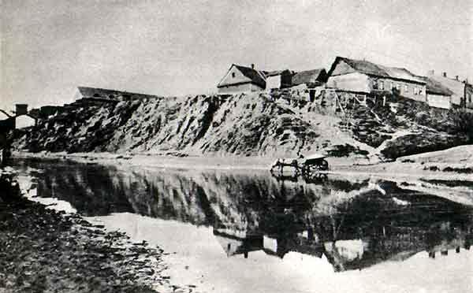

Mensk, as they called it in the past, grew long and wide. More often people travelled there on foot, but later they began to use horse carts. Horse carts became very popular and got the name *konka*.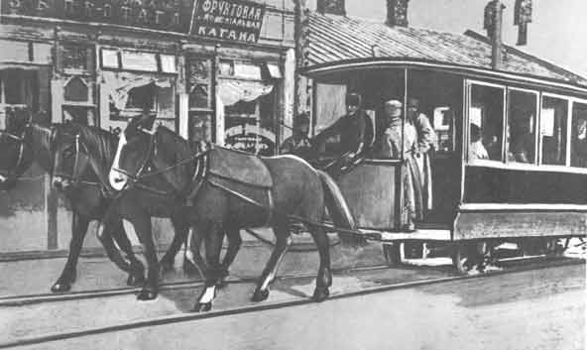

The city became more and more beautiful. New buildings, parks, streets and squares appeared. But when in 1941 fascists came they destroyed the city completely.

Soviet soldiers set Minsk free in 1944. Everybody knows this great date – the 3-rd of July, when our capital became free. Now in Victory square we can see the Monument with the Eternal Flame to those who liberated the city. There are always flowers at the foot of it.

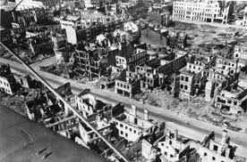

**APPENDIX 4**

**P1:** As you know, the theater begins with a hanger , and the city begins with the station. A new ultra-modern railway station was opened in Minsk in the early 2000s . And now it is one of the attractions of the city.

**P2:** The national library was opened in 2006. There are 22 floors and 20 reading rooms. It has it’s own Book museum and observation point on the top of the library. A statue of Francysk Skaryna stands near the entrance of the library.

**P3:** Belarusian Opera and Ballet House is the only opera theatre and the largest theatre in our republic. It is the main musical and theatrical scene of the country.

**P4:** Church of Saints Simon and Helena is situated on Independence Square. People name it " Red Church ". This religious building is the most famous sightseeing in Minsk.

**P5:** October Square is the center of Minsk. It is most famous as a place of celebrations, public events and an outdoor skating rink during the winter. It is the place for the main fur-tree in our country.

**P6:** The Trinity Suburb was built in the 18th century. Nowadays there are a lot of bars and cafes are situated there. Famous Belarusian poet Maxim Bogdanovich was born there.

**P7:** Maksim Gorky Central Children’s Park is situated near Victory Square. Here is a small observatory and planetarium. Children and grown-ups can have a rest there.