**Thank you for the lesson!**



K. Zayats

**Meals in Britain and in Belarus**

**Pupil’s workbook**

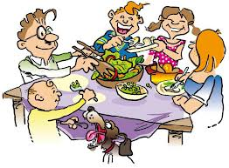

**Lepel, 2014**

**Ex. 1 Match 2 parts of the proverbs.**

1. An apple a day
2. Health is better than
3. Healthy mind in
4. Early to bed and early to rise,
5. a healthy body.
6. keeps the doctor away.
7. wealth.
8. makes a man healthy, wealthy and wise.

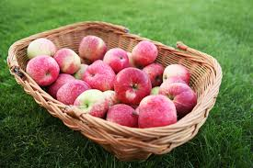

**Ex. 8 .Divide the words into 2 categories: countable and uncountable.**

~~Apple sugar~~  sandwich honey

butter biscuit sweet

banana tea sausage jam

vegetable fruit egg

|  |  |
| --- | --- |
| **countable** | **uncountable** |
| Apple  ________________  ________________  _________________  _________________  ___________________  ________________  __________________  __________________ | Sugar  __________________  ___________________  ___________________  __________________  ____________________  ____________________  ___________________  ___________________ |

**Hometask**

**PB p. 9 ex. 2b Write about meals in your family.**

**Ex. 6 Answer the questions:**

1) What do Belarusian people eat for breakfast?

2) When do we have breakfast?

3) What do Belarusian people eat for lunch?

4) Where do you have lunch: at home or at school?

5) When do we have lunch?

6) What do Belarusian people eat for dinner?

7) When do we have dinner?

**Ex. 7 Complete the table, using the help box**

**Help Box**

|  |
| --- |
| We usually have … at … o’clock.  We often have … for … .  Our favourite food is … .  Our favourite drink is … . |

**Ex. 2 Do the crossword**

1. 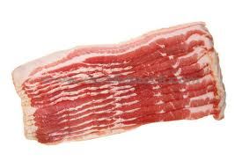 **2.** 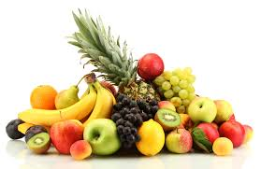

**3.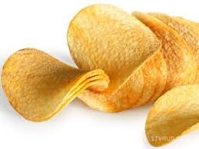 4.**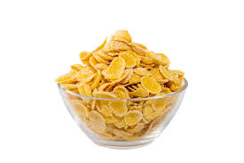

**5.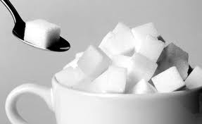 6.**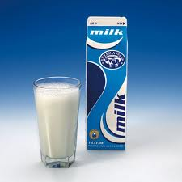

**7.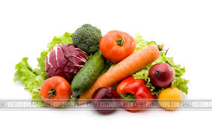 8. **

|  |  |  |  |  |  |  |  |  |  |  |  |  |  |  |  |  |
| --- | --- | --- | --- | --- | --- | --- | --- | --- | --- | --- | --- | --- | --- | --- | --- | --- |
| 1 | | | | | | |  |  |  | | |  |  | | | |
| 2 | |  |  | |  | |  |  |
|  |  | |  | |  |  |  | |  | | | | | | | | | | |
| 4 | | | | | | |  |  |  |  | | | | |  | | |  | |  | |
| 5 | | | | | |  |  |  |  |  | | | | | |  | | | | | |
|  |  |  |  |  | | | | | | | | | | | |
| 7 |  |  | |  | |  |  |  |  |  | | | |  | | | | |  | |  |
| 8 | |  | |  | |  |  |  |  | | | | | | | | | | | | |

**Ex. 3 Watch the video and answer the questions.**

1) What does British breakfast consist of?

2) What does British lunch consist of?

3) What does British dinner consist of?

And now say if the sentences are true or false:

**Ex. 4 Say if the sentences are true or false.**

1. The British eat pasta for breakfast.

2. The British don’t eat at home.

3. Dinner is the main meal of the day.

**Ex. 5 .Read the dialogue in your textbook (p. 7-8, ex. 1a) and answer the questions.**

1. When does Mike’s family have breakfast/ lunch/ dinner?
2. What do British people usually have for breakfast?
3. Where do many children have lunch?
4. What is “a packed lunch”?
5. What do British people have for dinner?
6. What do British people usually have with tea?